
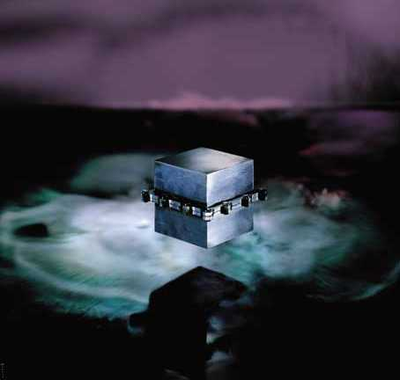

Comprehensive, Enterprise ready, File & E-Mail Security Solution for Individual Computers
PGP Security is a worldwide leader solving privacy and data confidentiality issues. Used by over 7 million people worldwide, PGP is the de facto encryption standard.
PGP for HMG provides complete e-mail and file security in a single, tightly integrated pack encryption.

PGP protects messages against unauthorized reading. Digital signatures guarantee authenticity and data integrity. PGP e-mail plug-ins support the majority of e-mail applications.

Quick, seamless integration of PGP’s tools encourages data security. The intuitive interface assures corporate policies are carried out daily. E-mails and files can be secured and authenticated.

Assurance Level: CESG Assisted Product Scheme – Restricted Level/Baseline Standard
Certification No: CAPS 0125183D
Evaluation Facility: CESG CAPS Office
10/2W03
PO Box 144
Cheltenham
Gloucestershire
CL52 5UE
PGP runs on all major desktop platforms. PGP provides the trusted personal security required for every employee desktop and laptop computer.
PGP Data Encryption

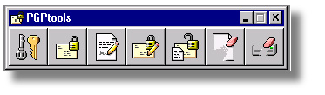
PGP for HMG
PGP Security, Protecting your Privacy

Features & Benefits
Encryption
- PGP de facto encryption standard. Used by over 7 million people. PGP strong encryption ensures privacy.
- Digital Signature for authentication and non-repudiation. You are guaranteed the author is who he claims to be. The sender cannot deny having sent the document.
- Signature Integrity to ensure that the data has not been altered

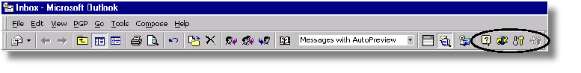
DRAFT COPY
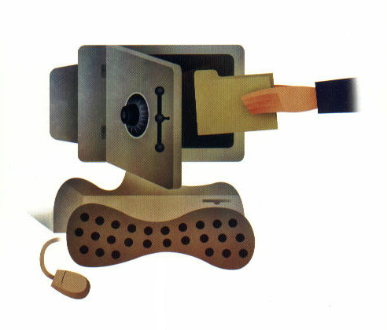
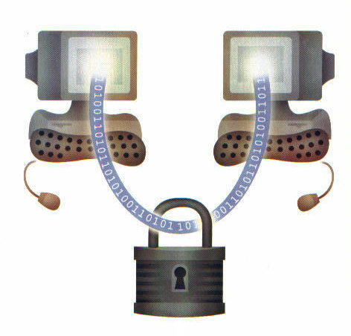
In Storage
Secure your data in storage: unlike other security software, PGP Corporate Desktop Suite not only encrypts data passing between two machines, it also protects information stored on your computer against internal attacks

In Transit
Protect your data in Transit: Using the widely accepted and highly trusted public key encryption system, you can maintain secure communications. Transferred data is always digitally signed to ensure proper authentication.

Messaging Platforms Supported
- Microsoft Outlook 97/98
- Microsoft Outlook Express 4.x and 5.x
- Lotus Notes 4.5.x, 4.6.x and 5.0
- Qualcomm Eudora 4.x

System Requirements
- PC: Windows 95b/98/NT4.0
- 16MB RAM
- 15MB free disk space
- Internet Eplorer 4.0.1 or greater with Extra Security 128-bit Browser option provided by Microsoft for RSA / CAPI functionaility (optional)

PGP Security Products
PGP Security, a Network Associates Company, protects your privacy through a full range of security products: Gauntlet Firewall, PGP Corporate Desktop Suite, PGPwireless, CyberCop and PGP E-ppliances.

Further information on this product can be obtained by contacting:

PGP Government Sales
Network Associates International Ltd.
227 Bath Road, Slough, Berkshire SL1 5PP
e-mail: hmg@pgp.com
Phone +44 (0) 1753 217500
Fax +44 (0) 1753 217520

For more information on products, worldwide services and support, contact your authorized PGP Security sales representative or visit us at:
3965 Freedom Circle
Santa Clara, CA 95054-1203
Tel (888) 747 3011
Fax (888) 203 9258
www.pgp.com

The De-facto Standard for E-mail Encryption is PGP
E-mail traditionally hops from system to system, where en-route
Interception is highly possible. Dials up connections provide
transparent mailboxes where e-mails await collection. It is an
Electronic era where business is conducted via e-mail. With over
7 million users, PGP is the de facto standard program for secure
E-mail and file encryption on the Internet. It’s public-key
Cryptography system enables the transmission of secure messages
Against unauthorized reading. Digital signatures added to
messages guarantee their authenticity and data integrity. PGP
E-mail plug-ins support the majority of e-mail applications so that
Users and recipients can maintain their e-mail programs.

DRAFT COPY

